**Assignment 11**

1. **BorderLayout Example**

**import java.awt.*;**

**import java.awt.event.*;**

**import javax.swing.*;**

**public class BorderLayoutExample {**

**public static void main(String[] args) {**

**JFrame frame = new JFrame("Border Layout Example");**

**frame.setLayout(new BorderLayout());**

**final JTextField textField = new JTextField("Enter the number");**

**JButton binary = new JButton("Binary");**

**JButton octal = new JButton("Octal");**

**JButton hex = new JButton("Hex");**

**final JLabel result = new JLabel("Result");**

**JPanel centerPanel = new JPanel(new FlowLayout());**

**centerPanel.add(binary);**

**centerPanel.add(octal);**

**centerPanel.add(hex);**

**frame.add(textField, BorderLayout.NORTH);**

**frame.add(centerPanel, BorderLayout.CENTER);**

**frame.add(result, BorderLayout.SOUTH);**

**binary.addActionListener(new ActionListener() {**

**public void actionPerformed(ActionEvent e) {**

**try {**

**int num = Integer.parseInt(textField.getText());**

**result.setText("Binary: " + Integer.toBinaryString(num));**

**} catch (NumberFormatException ex) {**

**result.setText("Invalid input");**

**}**

**}**

**});**

**octal.addActionListener(new ActionListener() {**

**public void actionPerformed(ActionEvent e) {**

**try {**

**int num = Integer.parseInt(textField.getText());**

**result.setText("Octal: " + Integer.toOctalString(num));**

**} catch (NumberFormatException ex) {**

**result.setText("Invalid input");**

**}**

**}**

**});**

**hex.addActionListener(new ActionListener() {**

**public void actionPerformed(ActionEvent e) {**

**try {**

**int num = Integer.parseInt(textField.getText());**

**result.setText("Hex: " + Integer.toHexString(num));**

**} catch (NumberFormatException ex) {**

**result.setText("Invalid input");**

**}**

**}**

**});**

**frame.setSize(300, 150);**

**frame.setVisible(true);**

**frame.setDefaultCloseOperation(JFrame.EXIT_ON_CLOSE);**

**}**

**}**

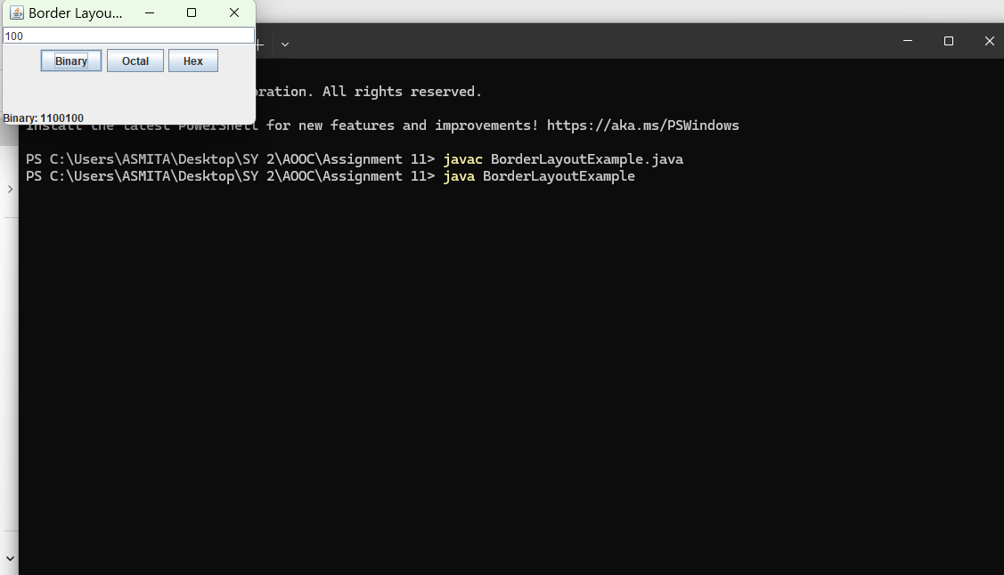

1. **FlowLayout Example** – Checkbox GUI

import java.awt.*;

import javax.swing.*;

public class FlowLayoutExample {

public static void main(String[] args) {

JFrame frame = new JFrame("Flow Layout Example");

frame.setLayout(new FlowLayout(FlowLayout.LEFT, 10, 20));

JCheckBox java = new JCheckBox("Java");

JCheckBox python = new JCheckBox("Python");

JCheckBox cpp = new JCheckBox("C++");

frame.add(java);

frame.add(python);

frame.add(cpp);

frame.setSize(300, 100);

frame.setVisible(true);

frame.setDefaultCloseOperation(JFrame.EXIT_ON_CLOSE);

}

}

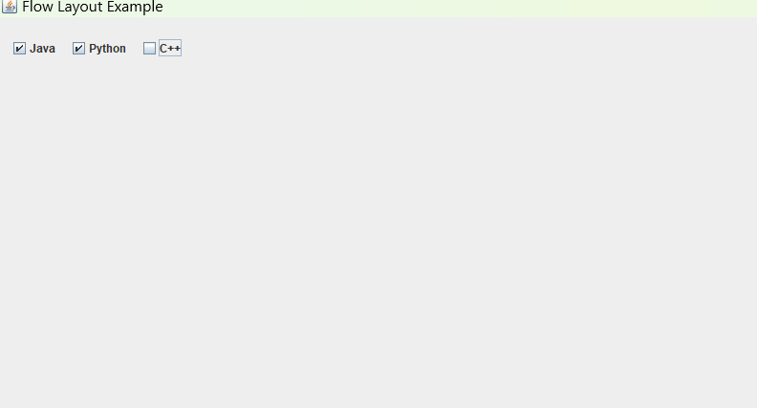

1. **GridLayout Example** – Swapping Numbers

import javax.swing.*;

import java.awt.*;

import java.awt.event.*;

public class GridLayoutExample {

static JButton[] buttons = new JButton[6]; // Moved outside main()

public static void main(String[] args) {

JFrame frame = new JFrame("Grid Layout Example");

frame.setLayout(new GridLayout(2, 3));

for (int i = 0; i < 6; i++) {

buttons[i] = new JButton(String.valueOf(i + 1));

frame.add(buttons[i]);

final int index = i; // make index effectively final

buttons[i].addActionListener(new ActionListener() {

public void actionPerformed(ActionEvent e) {

int swapIndex = (index + 1) % 6;

String currentText = buttons[index].getText();

String temp = buttons[swapIndex].getText();

buttons[swapIndex].setText(currentText);

buttons[index].setText(temp);

}

});

}

frame.setSize(300, 150);

frame.setDefaultCloseOperation(JFrame.EXIT_ON_CLOSE);

frame.setVisible(true);

}

}

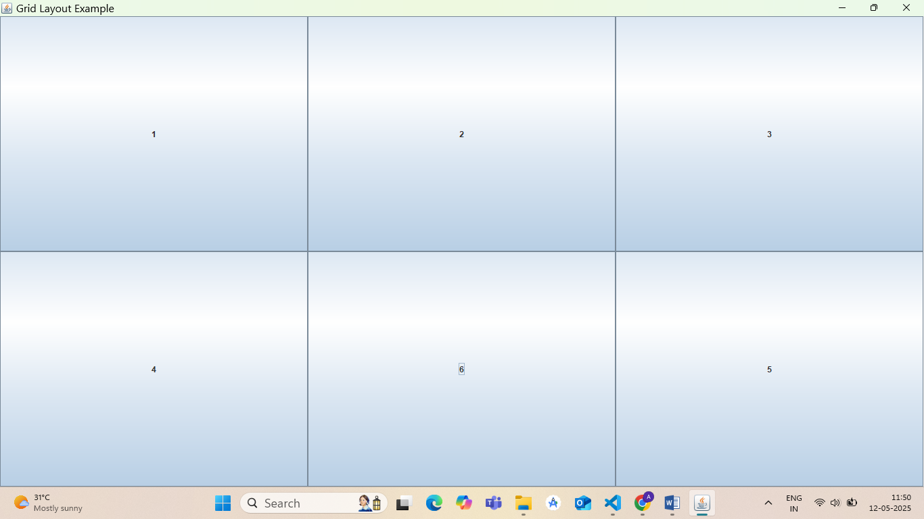

1. **Applet Example** – Factorial Program

import java.applet.*;

import java.awt.*;

import java.awt.event.*;

/*

<applet code="FactorialApplet.class" width=400 height=200></applet>

*/

public class FactorialApplet extends Applet implements ActionListener {

TextField input;

Label result;

Button compute;

public void init() {

input = new TextField(10);

compute = new Button("Compute Factorial");

result = new Label("Result will appear here");

add(new Label("Enter a number:"));

add(input);

add(compute);

add(result);

compute.addActionListener(this);

}

public void actionPerformed(ActionEvent e) {

try {

int num = Integer.parseInt(input.getText());

int fact = 1;

for (int i = 1; i <= num; i++) {

fact *= i;

}

result.setText("Factorial: " + fact);

} catch (NumberFormatException ex) {

result.setText("Invalid input");

}

}

}

<html>

<body>

<applet code="FactorialApplet.class" width="300" height="100">

</applet>

</body>

</html>

